**GAME DESIGN DOCUMENT**

**RUNNER**

**Tomi Laakkonen 283568**

**Game Design Document**

1. ***Executive Summary, Quick overview***

***Runner is an endless runner game that is a user-friendly game. Without high requirements, it can be run with every device and it generates randomly a unique level each time you play. It is a progressive running game where the speed increases rapidly and you get a point per second while you are playing.***

1. ***Target Audience***

* ***Mobile gamers***
* ***PC gamers***
* ***No specific age/gender audience***

1. ***Main Characters***

***There is only one character, the Runner.***



***4. Main Features***

***A randomly generated level each time you spawn and progressive speed while playing.***

*4.1 Main mechanics*

*Jump, increasing speed. Randomly generated platforms.*

*4.2 Movement*

*Automatic running, jump from command. The jump can be adjusted on how long you press the jump button (space or mouse 1).*

*4.3 Physics*

*Physics is close to the moon rather than earth.*

*4.4 Multiplayer mode*

*There is none.*

1. ***Genre, Setting, Concept Art book\****

* ***Endless Runner***
* ***Art is from Unity free assets***

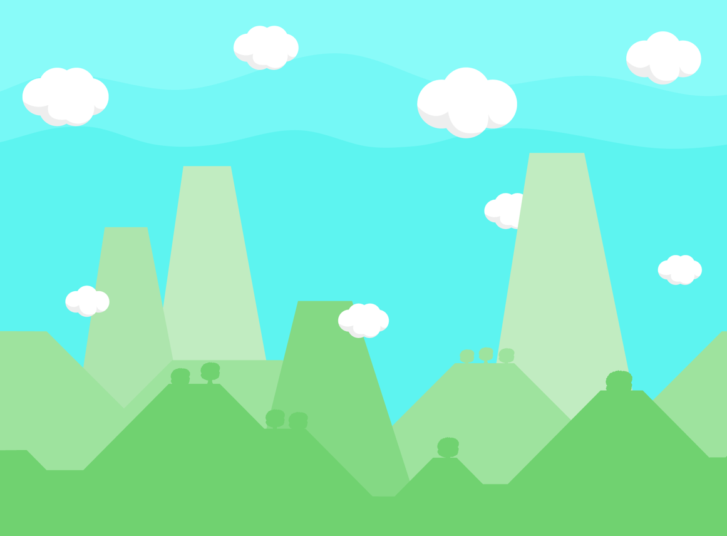

1. ***Enemies, NPCs, Other objects***

***There is none.***

1. ***Story board, script\****

***Randomly generated platforms each time you play. There is no seed function to replay a good seed as an example.***

***8. Technical definitions, Tech guide\****

*8.1 Platforms, versions*

* *1.0.0 MVP released.*

*8.2 Control Scheme*

* *Space or mouse button 1 with PC export.*
* *In the future for mobile export a touch is enough.*

*8.3 Limitations*

* *Only PC export released for now.*

***9. Business definitions\****

*9.1 In-app purchases*

* *Respawn in the future.*

*9.2 DLC packs*

* *Powerups in the future.*

***10. Outsourced/Bought Assets***

*Game character, background, and platforms:*

[*https://assetstore.unity.com/packages/2d/environments/free-platform-game-assets-85838*](https://assetstore.unity.com/packages/2d/environments/free-platform-game-assets-85838)

*Sounds:*

*https://assetstore.unity.com/packages/audio/sound-fx/8-bit-retro-rampage-free-edition-7946*